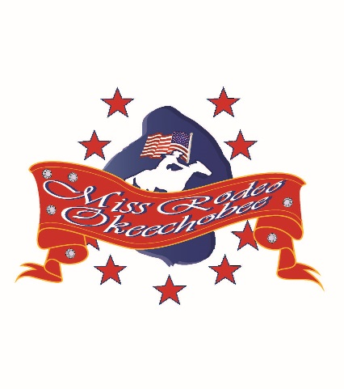Miss Rodeo Okeechobee Pageant Book Sales

Thank you for your purchase! These funds assist in the support of the rodeo queen pageant and the program throughout the year.
Ad sizes and prices: Page size 8 x 11
Full color inside cover and inside back cover, full page: $175.00
Inside pages in Black and white: Full page $140.00
Half Page $70.00
Quarter Page $35.00
Each young lady is to sell 4 pages of advertisements. 20 points will be added to the total score for completed ad sales. If you have any questions please contact Michelle Harper at 863-634-6397. Please include any photos and wording with this form,
Purchaser:__________________________________________________________

Name of person responsible for ad approval:______________________________

Contact info: Phone:__________________________________________________
Address:____________________________________________________________

Payment to be attached to form also: Make checks to OCCA, memo; Miss Rodeo Okeechobee. A receipt will be available if needed.

